**Retrieve Student Data from a Text File with the Option of Sorting and Searching.**

**Pre-populate student data in Notepad:**

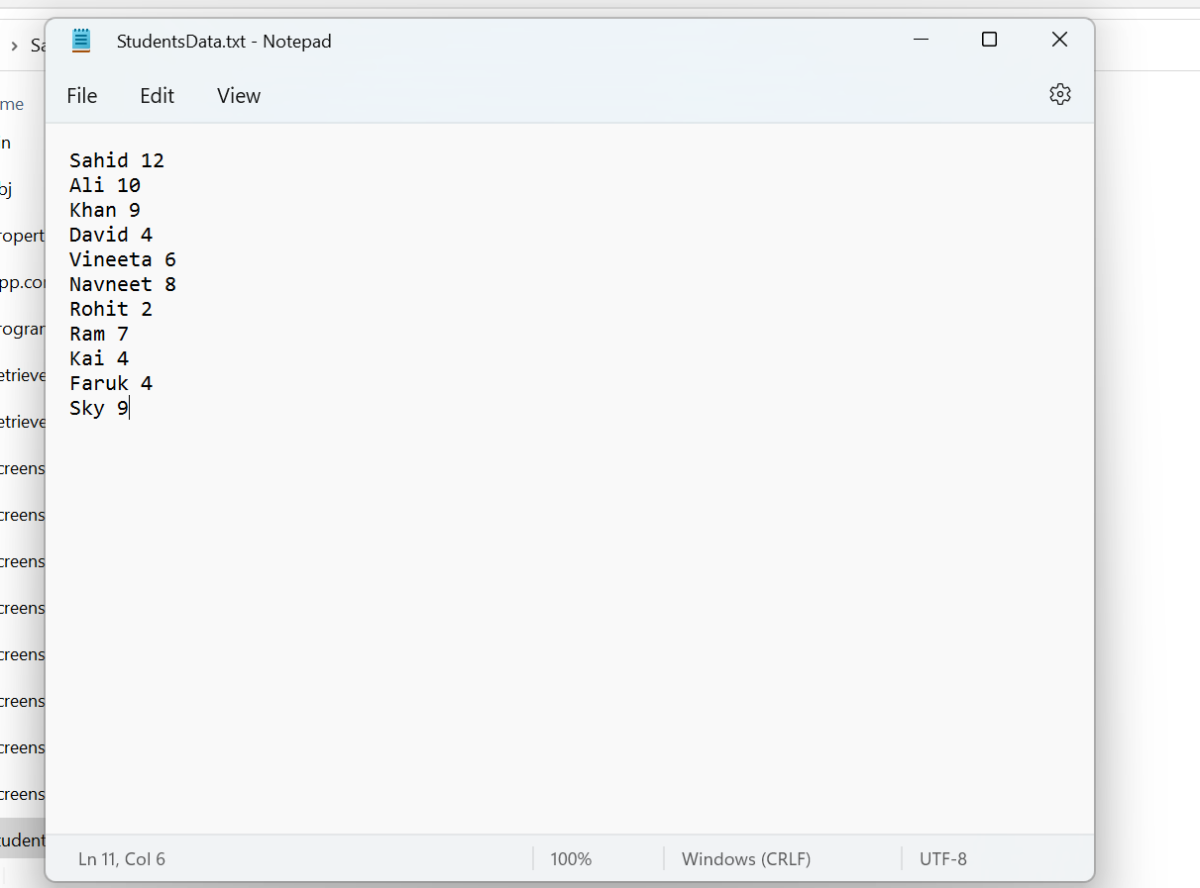

**Program that will retrieve the data from StudentsData.txt with the Option of Sorting and Searching:**

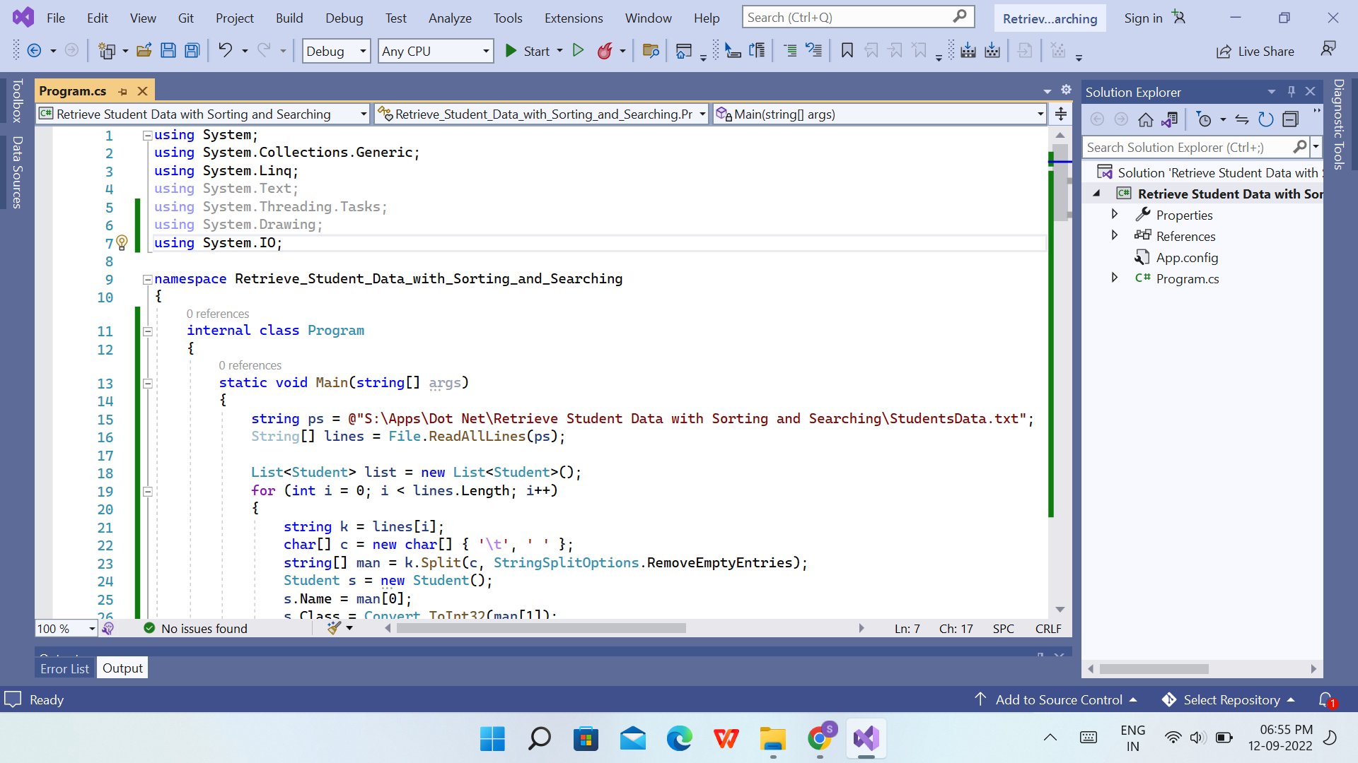

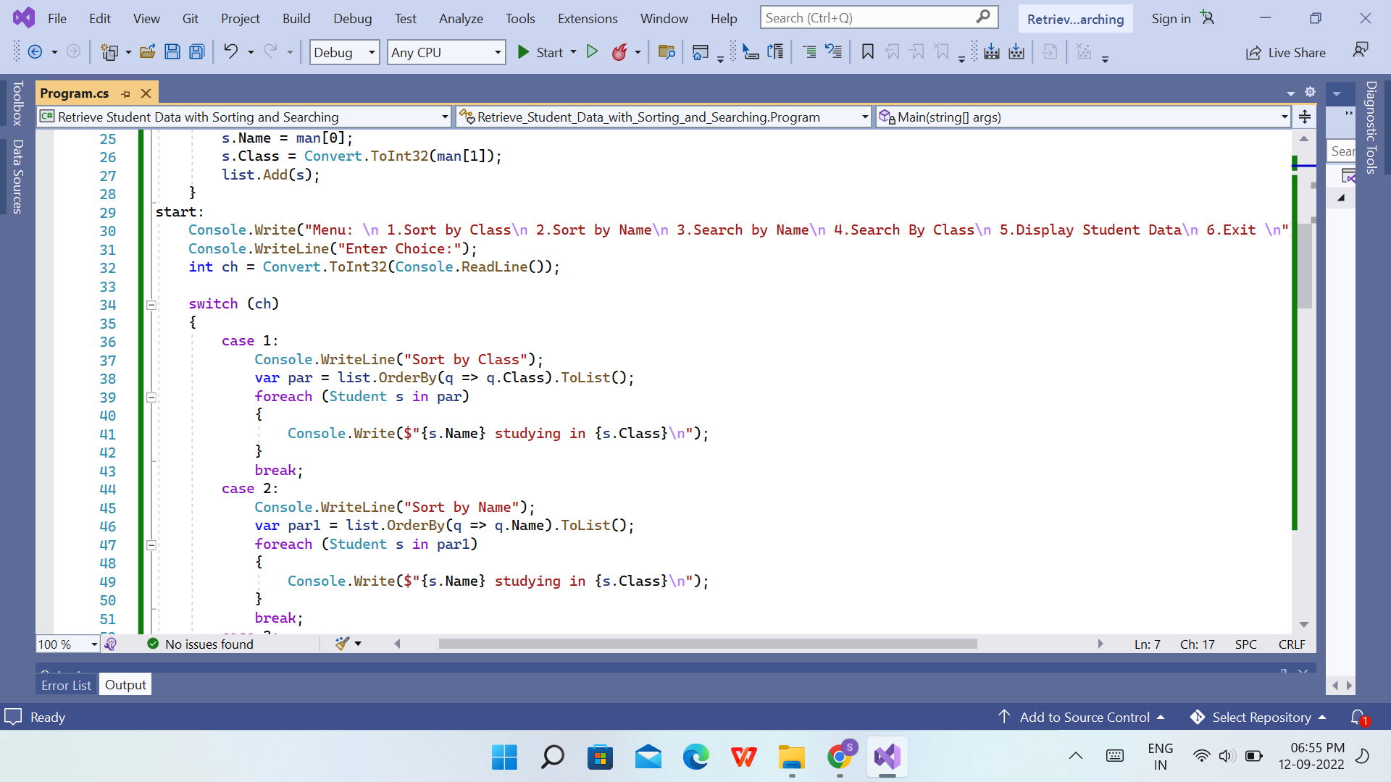

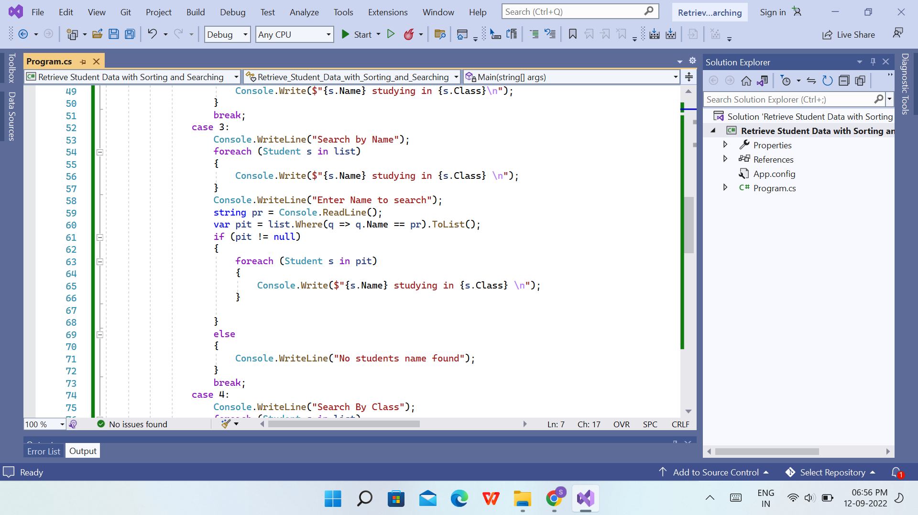

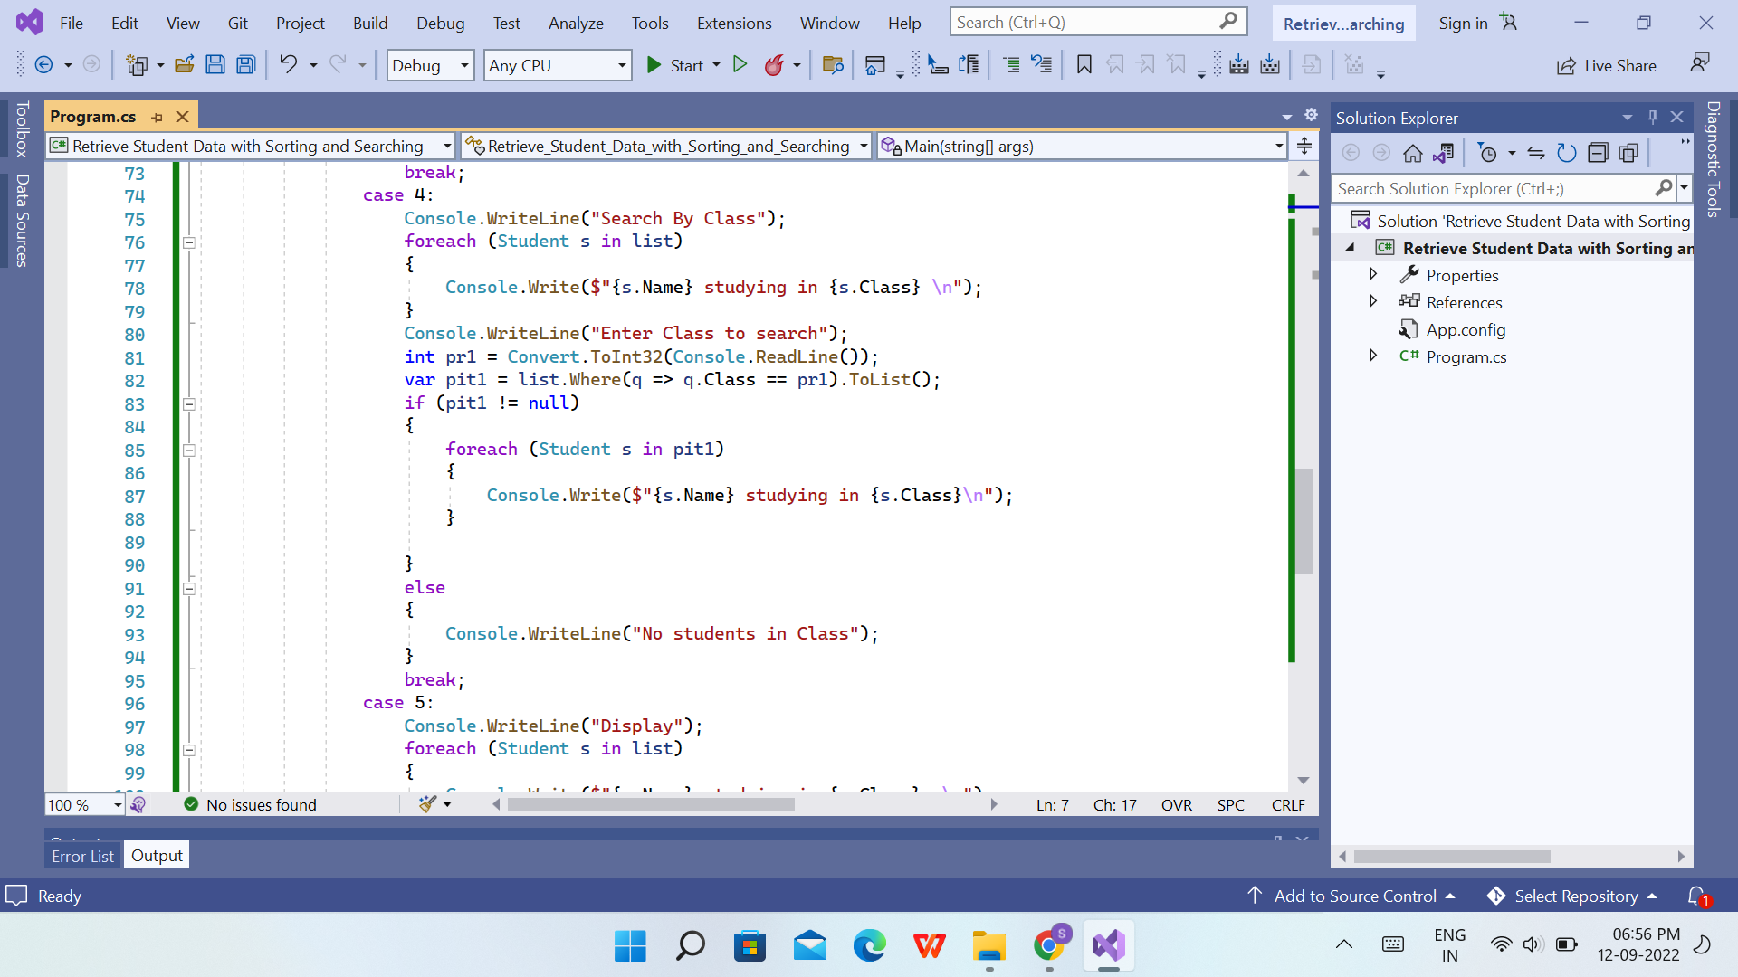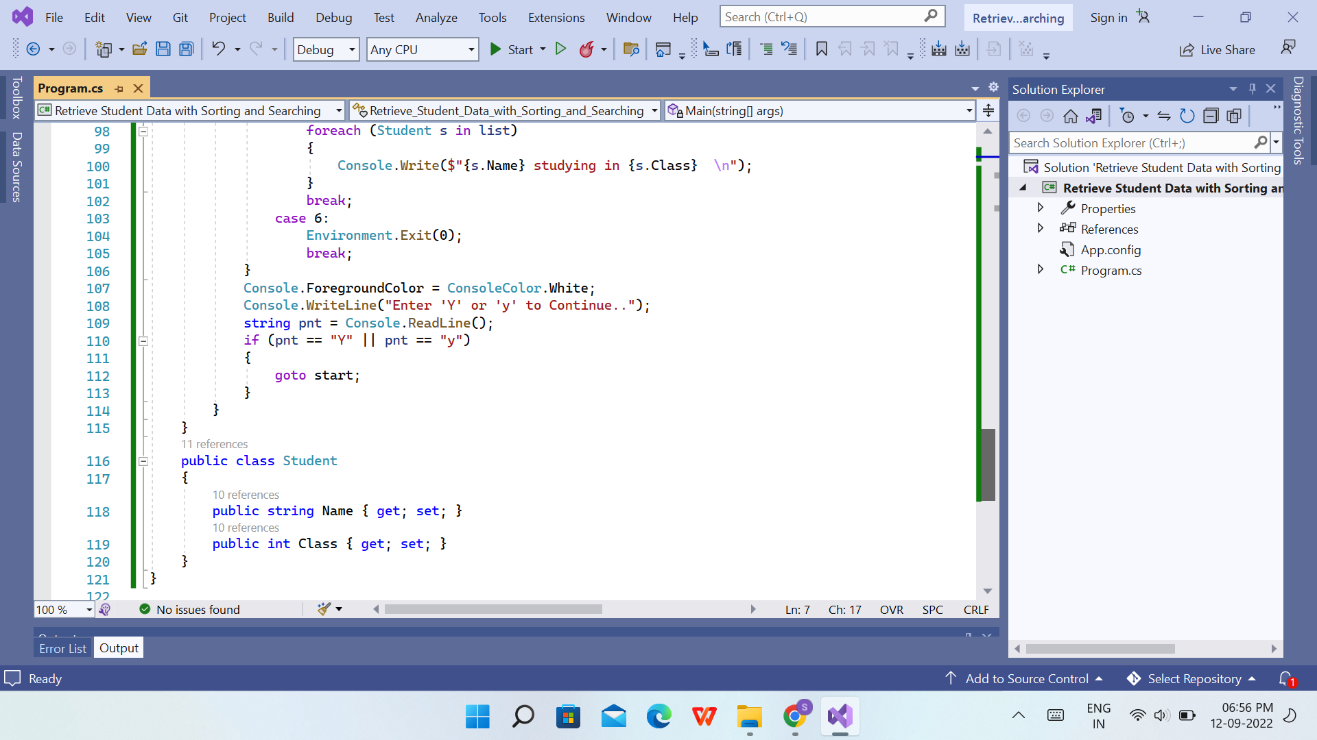

**Output of Program that will retrieve the data from studentsfile.txt with the Option of Sorting and Searching:**

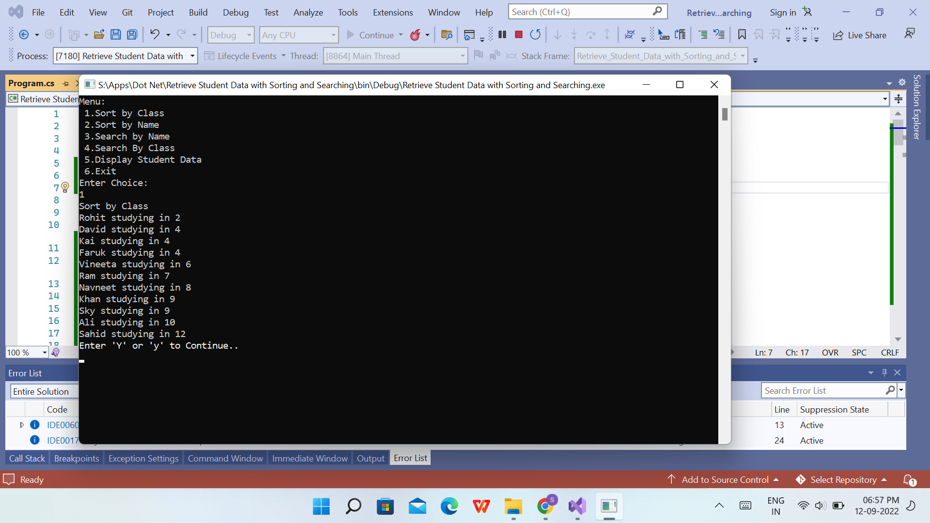

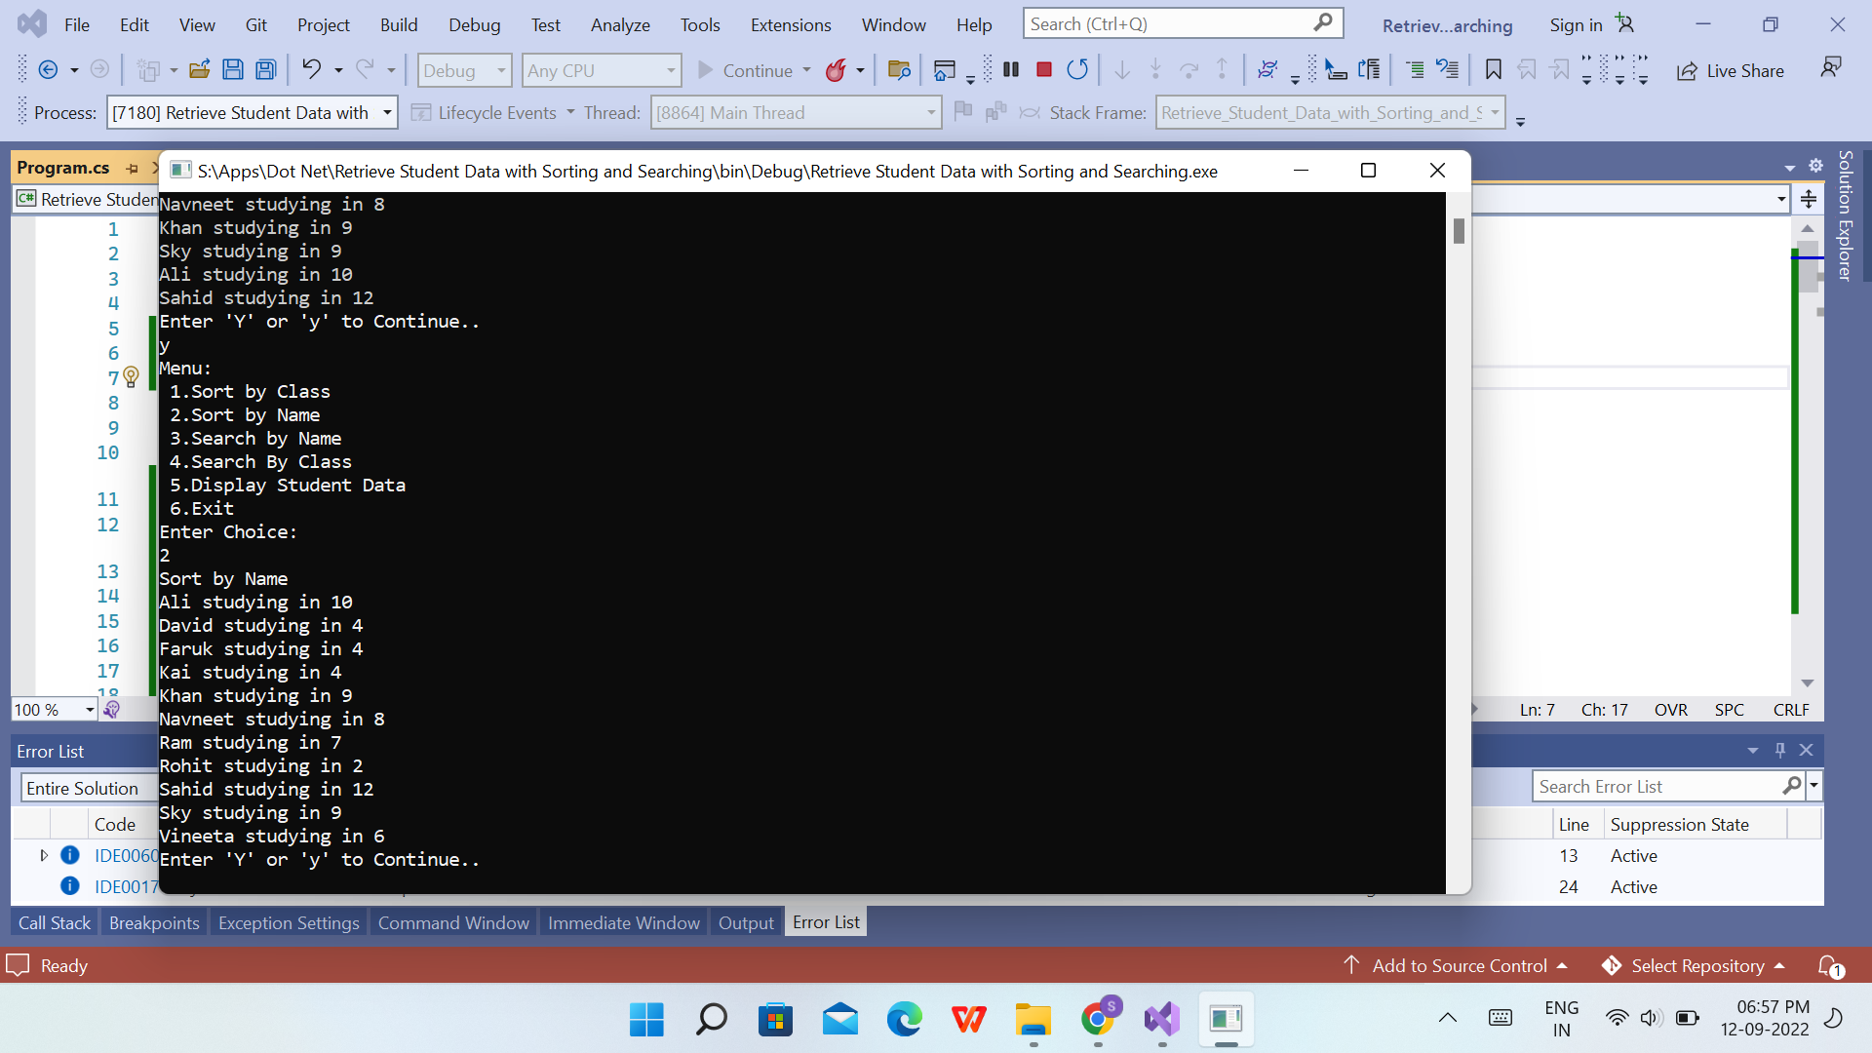

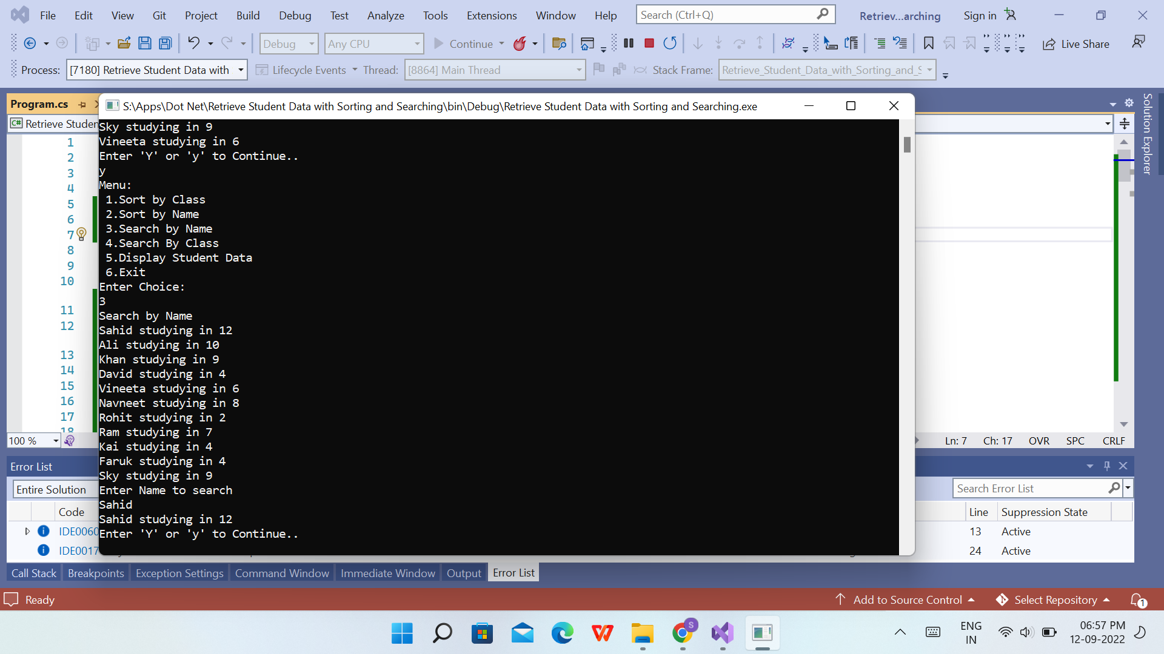

**Sahid Ali Khan**

**2529998**